Automatic Fall Detection using Wearable Inertial Sensors
EECE5644 Iteration 5: Final Project Report
Team Members: Elizabeth Fallat, Darren Easler, Majd Khalaf
GitHub Repository: https://github.com/emfallat/EECE-5644-Final-Project
Abstract:
Falls among older adults are a leading cause of injury and loss of independence, making accurate fall detection an important healthcare application. In this project, we used the FallAllD dataset, which contains 6,605 labeled recordings from wearable inertial sensors collected from 15 subjects. The dataset includes 35 different fall types and 44 activities of daily living (ADLs), with data captured by accelerometers, gyroscopes, magnetometers, and barometers worn on the neck, wrist, and waist.

After cleaning the data, we engineered 54 statistical features from each recording and split the dataset by subject so that no individual appeared in more than one of the training, validation, or test sets. We then trained and tuned five supervised machine learning models: Logistic Regression, Support Vector Machine (SVM), Random Forest, XGBoost, and a Multi-Layer Perceptron (MLP). Hyperparameters were optimized using RandomizedSearchCV, and the final models were evaluated on unseen subjects.

The tuned Random Forest model achieved the best overall performance, with 94.3% accuracy, 86.0% recall, an F1-score of 88.3%, and a ROC-AUC of 0.982 for fall detection. Feature importance analysis also showed that accelerometer-based features, especially statistics from the vertical (z) axis and RMS values, were the most useful for distinguishing falls from normal daily activities. In contrast, the barometer contributed very little and sometimes reduced model performance when combined with the other sensors.

Overall, the results suggest that a relatively simple set of engineered features combined with a Random Forest classifier can accurately detect falls in data from people the model has never seen, making it a promising approach for wearable fall detection systems.

Introduction:
Falls are one of the leading causes of injury among older individuals which can have a major impact on a persons health. The main goal is to be able to detect a fall automatically and significantly improve response time and health outcomes. Wearable sensors such as accelerometers, gyroscopes, magnetometers, and barometers are a practical way to monitor a person's movement without requiring cameras or some other fixed infrastructure. The main challenge is turning the large amount of sensor data that these devices collect into a reliable decision about whether or not an individual was just doing an activity of daily living (ADL) or they fell.
This project builds a complete machine learning pipeline for that problem using the FallAllD dataset, from raw sensor files through data cleaning, feature engineering, model training, tuning, and evaluation on subjects the models have never seen. Our goal was to not only to build an accurate fall detection model, but to also determine which sensors and features actually drive good performance, determine how much hyperparameter tuning helps, and determine how well the final model could generalize to real users.

Problem Definition:
This project is set up as a supervised binary classification problem. Using the data collected from wearbale sensors, the goal is to predict whether or not the activity was an activity of daily life (ADL) or a fall. These recordings were converted to a fixed set of features and the model then predicts a label where 0 represents an ADL and 1 represents a fall.
This is a challenging problem because the dataset is imbalanced, the cost of prediction errors is not equal and the model needs to work on people it has never seen before. First of all, the dataset is imbalanced, which means that falls only make up about 25% of the recordings. Secondly, the cost of prediction errors is not equal meaning that missing an actual fell, which is a false negative, is much more serious than a false alarm, or a false positive. And finally, the model needs to determine a fall vs ADL for every new user, including people it hasn’t seen before, which they may have a different baseline as well.
To address some of these challenges, we used class weighing and oversampling to handle imbalances. We also used recall and F1-score during evaluation to account for the higher cost of missed falls. And finally, we split train, validation and test based on subjects, rather than splitting individual recordings.

Dataset Description:
FallAllD is an open, multivariate time-series dataset that contains simulated falls and normal activities for 15 participants. Each participant wore 3 sensor devices that provided measurements from multiple body positions including wrist, waist and neck. Each recording is represented by 4 files: triaxial accelerometer (A), barometer (B), triaxial gyroscope (G) and triaxial magnetometer (M).

Sensor | Channels | Sampling rate
Accelerometer | x, y, z acceleration (3) | 238 Hz
Barometer | Pressure and temperature (2) | 10 Hz
Gyroscope | x, y, z angular velocity (3) | 238 Hz
Magnetometer | x, y, z magnetic field (3) | 80 Hz

The sensor streams have different sequence lengths because they were sampled at different rates. So, they must be aligned, resampled, or summarized during preprocessing. This dataset is appropriate for this project and determining falls because it provides labeled examples of the positive class (35 kinds of falls) and the negative class (44 Activities of Daily Living). This dataset also includes measurements from multiple body positions and participants.

Each individual data file has a different name based on the device, activity, trial and sensor. A filename such as S01_D1_A013_T01_A.dat identifies subject S01, device D1, activity A013, trial T01, and the accelerometer sensor A. The same recording key has corresponding B, G, and M files. Thus, the 26,420 individual files represent 6,605 complete sensor-device recordings.

The supplied ActivityID2Str.m mapping defines IDs 1–44 as activities of daily living and IDs 101–135 as falls. Accordingly, A001–A044 are encoded as ADL (0), while A101–A135 are encoded as fall (1). For example, S01_D1_A013_T01_A.dat is an ADL recording, while S01_D1_A101_T01_A.dat is a fall recording.

Data Cleaning and Preprocessing:
To start, we converted all the individual .dat files to a singular pkl file containing all the subject/device/activity trials. The raw data contained 26,420 files and we started by parsing each filename to get the respective data out and then grouped the 4 sensor files that had the same recording and consolidated it into a single data frame with one row per recording, for a total of 6,605 rows.

Missing and Duplicate Values
Once the pkl file was loaded, we checked for missing values, both at the row level and within each sensor array. No data was missing and no NANs were present, so no logic was needed to account for missing values. Then we checked for duplicate values and confirmed that there were exactly 6,605 unique keys (composed of subject, device, activity, and trial number) with no duplicates.

Detecting and Treating Outliers
Next, we examined each sensor channel against the known hardware specks (including ±8g for the accelerometer, ±2000 dps for the gyroscope), which we used to flag invalid values. Invalid values are classified as readings that are non-finite or outside of the range of what the sensor hardware can actually produce. Also, large accelerometer and gyroscope peaks were not removed solely because they were statistical outliers. Those peaks were intentionally left untouched because they could distinguish a fall from an ADL (activity of daily living). And when checking how many samples were invalid, we found there were 47 invalid Gyroscope samples that we corrected using linear interpolation from neighboring valid samples.

Encoding Categorical Variables
We encoded the target variable directly from the ActivityID. So, values from 1–44 were labeled as ADL (0), and values from 101–135 were labeled as fall (1). Subject identifiers were retained only to have a subject-wise split of train, validation, and test data later on. Device location (neck, wrist and waist) was also mapped from the numeric device code and one-hot encoded.

Feature Scaling and Normalization
Before splitting, we scaled each of the 4 raw sensor channels (accelerometer, gyroscope, magnetometer, and barometer) to zero mean and unit variance. This was done because their ranges differed enormously and would otherwise dominate any model by magnitude and not by signal importance. The scaling parameters were only computed using the training data to avoid data leakage, and then they were applied to the validate and test subjects.

Training, Validation, and Testing Split
The training/validation/test split was done at the subject level rather than by splitting individual recording to make sure that no subject’s data appeared across more than one split. Using a random fixed seed, 11 subjects were assigned to training, 2 to validation and 2 to test. Also, the fall/ADL class balance was steady across all three splits with roughly 75% ADL and 25% fall in each.

Feature Engineering and Selection
After the data set was scaled and split, we engineered the features and selected specific ones to fit our modeling needs. For each of the 4 sensor channels, we computed 6 statistics: mean, median, standard deviation, minimum, maximum and root mean square. Then we reduced this feature set using variance thresholding to remove constant and near-constant features, along with correlation filtering to drop one feature from every pair correlated more than 95%. This brought the final feature count to 54, which was used to build X_train, X_val and X_test.

Exploratory Data Analysis:
Before choosing a feature-based approach, we first wanted to verify that falls and activities of daily living, ADLs, showed noticeable differences in the raw sensor signals. To do this, we examined the accelerometer waveforms.

Figure 1 compares examples of raw accelerometer magnitude signals from ADLs and falls across the three device locations. ADL movements, such as walking or clapping, generally show repetitive and predictable patterns, while falls contain a more distinct pattern: a short decrease in acceleration caused by free-fall followed by a sharp impact peak. This impact event is highlighted with the red dashed line and represents the type of movement that features such as maximum value, RMS, and standard deviation are designed to capture.
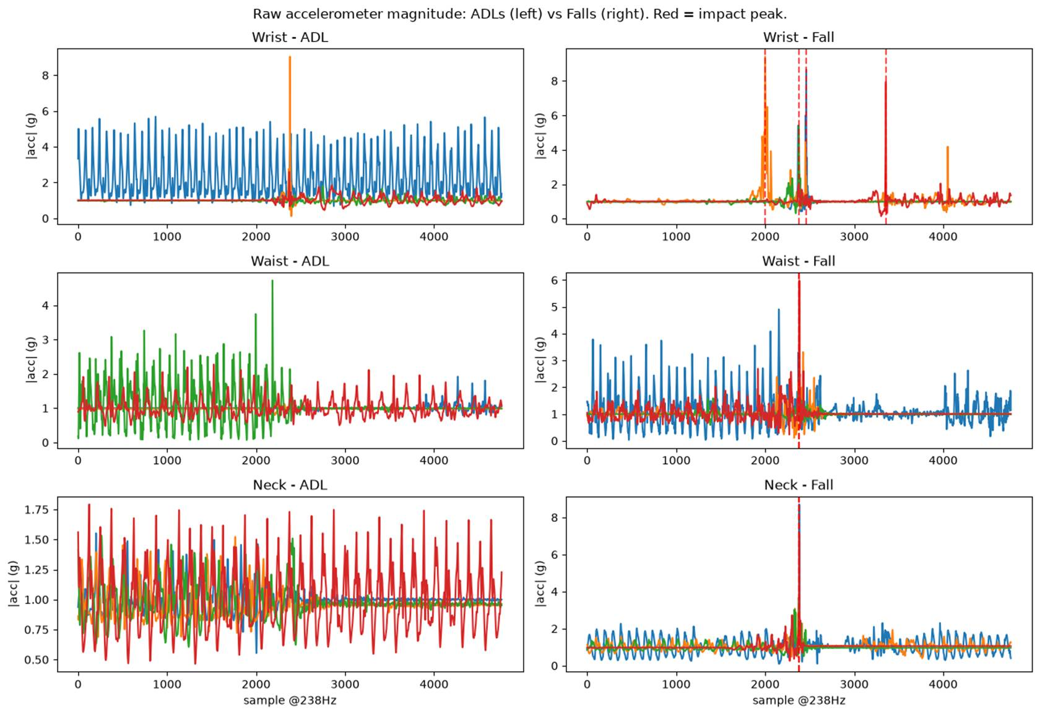
Figure 1. Raw accelerometer magnitude: ADLs (left) vs. Falls (right) at wrist, waist, and neck. Red dashed lines mark the impact peak.

Figure 2 shows the correlation structure of the original 69-feature engineered dataset before feature selection. The strong red and blue blocks represent groups of highly correlated features, meaning some features were providing similar information. For example, standard deviation and RMS values calculated from the same sensor axis showed very similar behavior. This supported the use of the |r| > 0.95 correlation filter to remove redundant features and create a smaller, more efficient feature set.
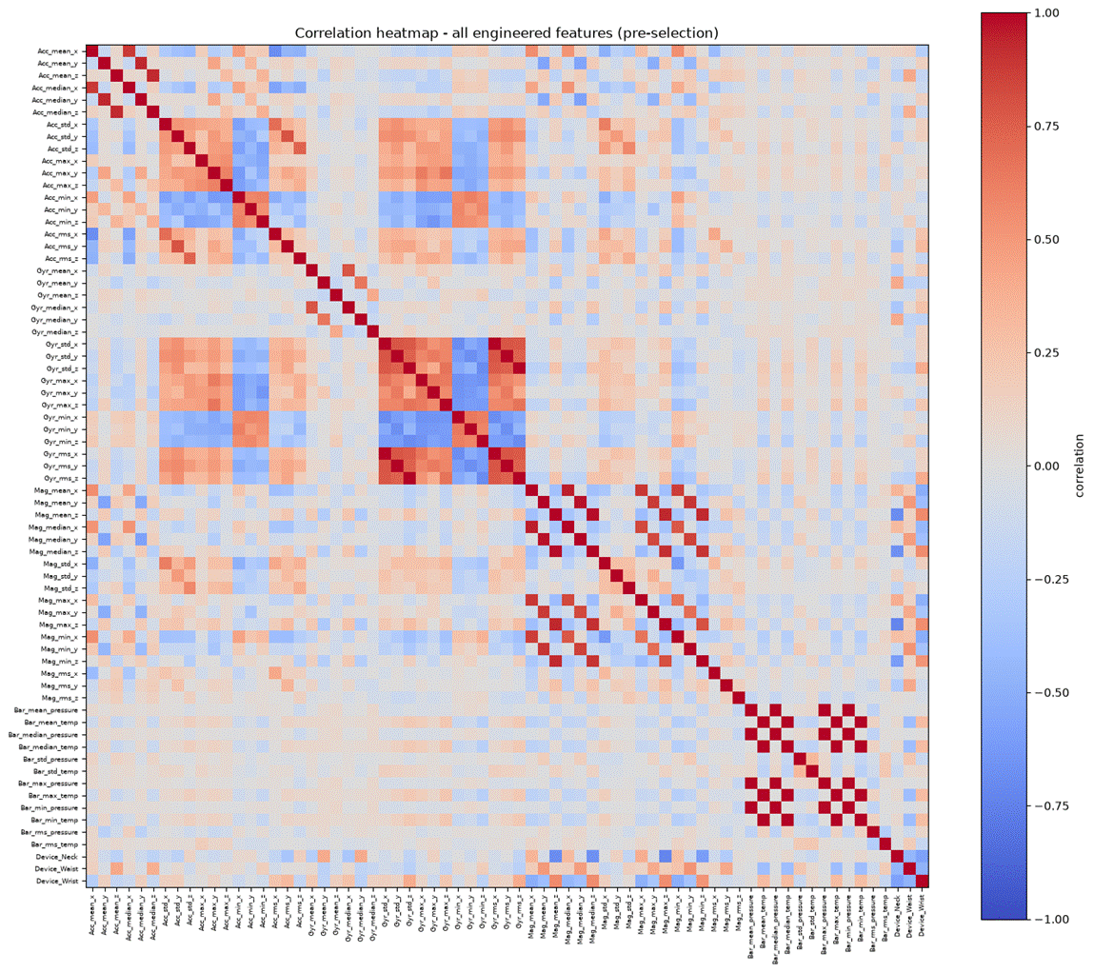
Figure 2. Correlation heatmap of the full (pre-selection) 69-feature engineered set. Dense red/blue blocks indicate highly correlated feature pairs.
Figure 3 displays the distributions of the four features that were ranked as most important by the Random Forest model, separated by class. The ADL and Fall recordings show noticeable differences in these feature ranges, especially for acceleration minimum values and maximum values. Falls generally contain more extreme acceleration values, which matches the patterns observed in the raw waveform analysis and explains why these features contributed strongly to classification performance.

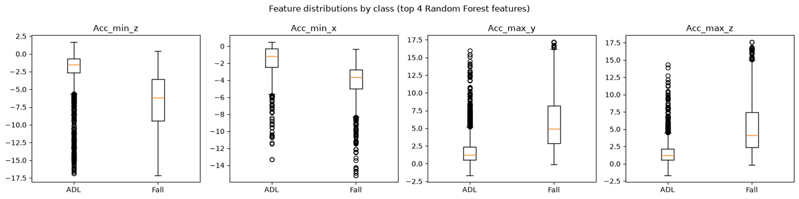
Figure 3. Distribution of the top 4 Random Forest features, split by class (ADL vs. Fall).

Class balance was also checked throughout the pipeline. The overall dataset contains approximately 74% ADL recordings and 26% fall recordings, and this ratio remained consistent within a few percentage points across the training, validation, and test splits. This ensured that model comparisons were not affected by one split having a significantly different class distribution.
Machine Learning Models:
Five supervised machine learning classifiers were implemented on the 54-feature, per-recording tabular dataset described previously.
Model Architecture / Configuration:
Model | Type | Configuration used | Why selected
Logistic Regression | Linear | class_weight=balanced, max_iter=5000 | Provides a fast and interpretable baseline to determine whether the engineered features are linearly separable.
SVM | Kernel (RBF) | class_weight=balanced, probability=True | Captures non-linear relationships between features while still performing well on smaller datasets.
Random Forest | Tree ensemble (bagging) | class_weight=balanced | A strong baseline for structured tabular data that also provides interpretable feature importance rankings.
XGBoost | Tree ensemble (boosting) | scale_pos_weight = 2.86 based on the ADL to Fall ratio | Uses sequential boosting to capture more complex feature interactions that may be missed by individual trees.
MLP | Feed-forward neural net | hidden layers, ReLU/tanh activation, Adam optimizer, early stopping | Tests whether a neural network can identify additional non-linear patterns compared to traditional machine learning approaches.

Class imbalance was handled differently depending on the model. For models that support class weighting, such as Logistic Regression, SVM, Random Forest, and XGBoost, the imbalance between ADL and fall recordings was addressed by increasing the importance of the minority fall class during training.

The MLP classifier in scikit-learn does not support a built-in class_weight parameter, so the fall class was balanced through random oversampling of the training data. This process duplicates existing fall examples until the number of fall recordings matches the majority ADL class. No synthetic data was created, and oversampling was only applied to the training set. During cross-validation, duplicated samples remained within the same fold as their original sample to prevent data leakage.

Model Training:
All five models were trained on the 4,483-row training split which included data from 11 sensors and 15 subjects. The models were then trained on the 54 standardized engineered features and then evaluated on the 1,035-row test split which contained 2 subjects that were completely excluded from training and hyperparameter tuning. This subject wise split provided more of a realistic evaluation of how the models would preform on new users.
For each model, the predicted probabilities were converted into class predictions using a 0.5 decision threshold. Then the performance was evaluated using accuracy, precision, recall, F1, and ROC-AUC.
Default (Untuned) Test Performance:
Model | Accuracy | Precision | Recall | F1 | ROC-AUC
Logistic Regression | 0.889 | 0.742 | 0.849 | 0.792 | 0.947
SVM (RBF) | 0.933 | 0.899 | 0.826 | 0.861 | 0.978
Random Forest | 0.941 | 0.899 | 0.860 | 0.879 | 0.981
XGBoost | 0.888 | 0.803 | 0.729 | 0.764 | 0.962
MLP | 0.920 | 0.857 | 0.814 | 0.835 | 0.972

Using the default hyperparameters, the Random Forest model achieved the strongest overall performance. It produced the highest accuracy, recall, F1-score, and ROC-AUC, while matching the SVM for the highest precision. The SVM also performed well, while XGBoost had the weakest results before tuning, particularly in recall and F1-score. These results show that the engineered features already provided strong separation between falls and ADLs, even before model optimization.

Hyperparameter Tuning:
Each model was tuned using RandomizedSearchCV (20 sampled configurations and scored on F1). A GroupKFold(4) cross validation strategy was used and grouped by SubjectID. This ensured that recordings from the same subject never appeared in both the training and validation portions of a fold, preventing data leakage during hyperparameter selection.
Model | Tuned hyperparameters | Best found
Logistic Regression | C ∈ {0.01–10} | C = 0.1
SVM (RBF) | C, gamma, kernel | C = 1, gamma = 0.01, kernel = rbf
Random Forest | n_estimators, max_depth, min_samples_leaf, max_features | n_estimators=200, max_depth=None, min_samples_leaf=1, max_features=sqrt
XGBoost | n_estimators, max_depth, learning_rate, subsample, colsample_bytree | n_estimators=800, max_depth=8, learning_rate=0.05, subsample=0.85, colsample_bytree=0.7
MLP | hidden_layer_sizes, alpha, learning_rate_init, activation | hidden_layer_sizes=(64,), alpha=1e-5, learning_rate_init=0.001, activation=tanh

Model | F1 (default) | F1 (tuned) | Recall (default) | Recall (tuned)
Logistic Regression | 0.792 | 0.788 | 0.849 | 0.857
SVM (RBF) | 0.861 | 0.831 | 0.826 | 0.798
Random Forest | 0.879 | 0.883 | 0.860 | 0.860
XGBoost | 0.764 | 0.802 | 0.729 | 0.760
MLP | 0.835 | 0.846 | 0.814 | 0.864

The impact of hyperparameter tuning was mixed rather than a consistent improvement across all models. Tuning provided the largest improvement for XGBoost and also improved the MLP, suggesting that these models benefited most from optimized configurations. Random Forest showed a smaller but consistent improvement, while Logistic Regression remained nearly unchanged. In contrast, the tuned SVM performed worse than its default version, indicating that the configuration selected during cross-validation did not generalize as well to the two held-out test subjects.
This difference is likely due to subject-level variation within the dataset. Since only a small number of subjects were available for validation and testing, cross-validation results can be somewhat sensitive to individual movement patterns. As a result, model selection based on grouped F1-score provides a useful estimate, but it may not always perfectly predict performance on completely unseen individuals.

Model Evaluation:
Model evaluation included both threshold-based metrics (accuracy, precision, recall, and F1-score) and a threshold-independent metric (ROC-AUC). While accuracy provides a general measure of correctness, recall and F1-score were prioritized because of the application context. In a fall detection system, missing an actual fall (false negative) is much more serious than generating a false alarm (false positive). ROC-AUC was also included because it measures how well each model separates the two classes across different decision thresholds, which is useful when selecting an operating point for a real deployment.

Model | Accuracy | Precision | Recall | F1 | ROC-AUC
Logistic Regression | 0.885 | 0.729 | 0.857 | 0.788 | 0.947
SVM (RBF) | 0.919 | 0.866 | 0.798 | 0.831 | 0.975
Random Forest | 0.943 | 0.906 | 0.860 | 0.883 | 0.982
XGBoost | 0.906 | 0.848 | 0.760 | 0.802 | 0.972
MLP | 0.922 | 0.829 | 0.864 | 0.846 | 0.971

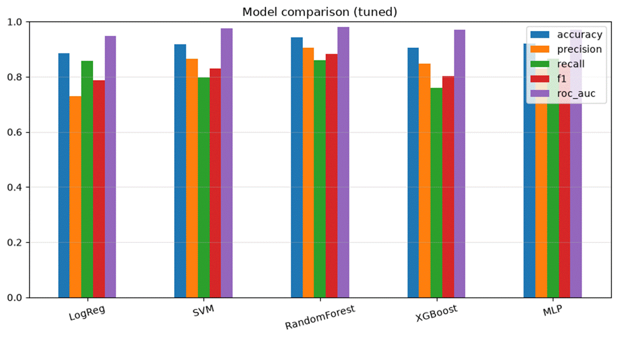
Figure 4. Tuned model comparison on the held-out test subjects.

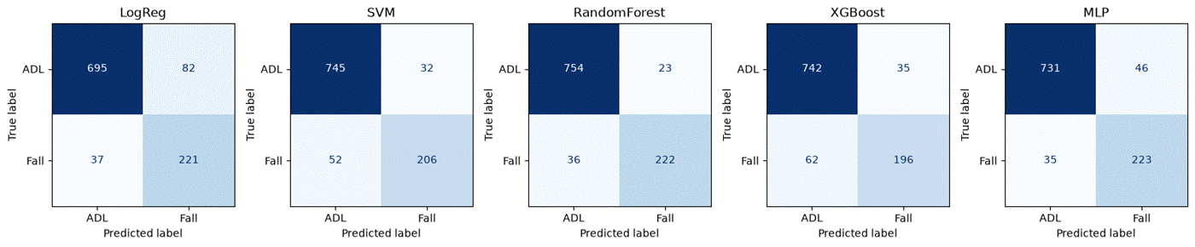
Figure 5. Confusion matrices for all five tuned models on the test subjects. The dominant error for every model is false alarms (ADL predicted as Fall) rather than missed falls.
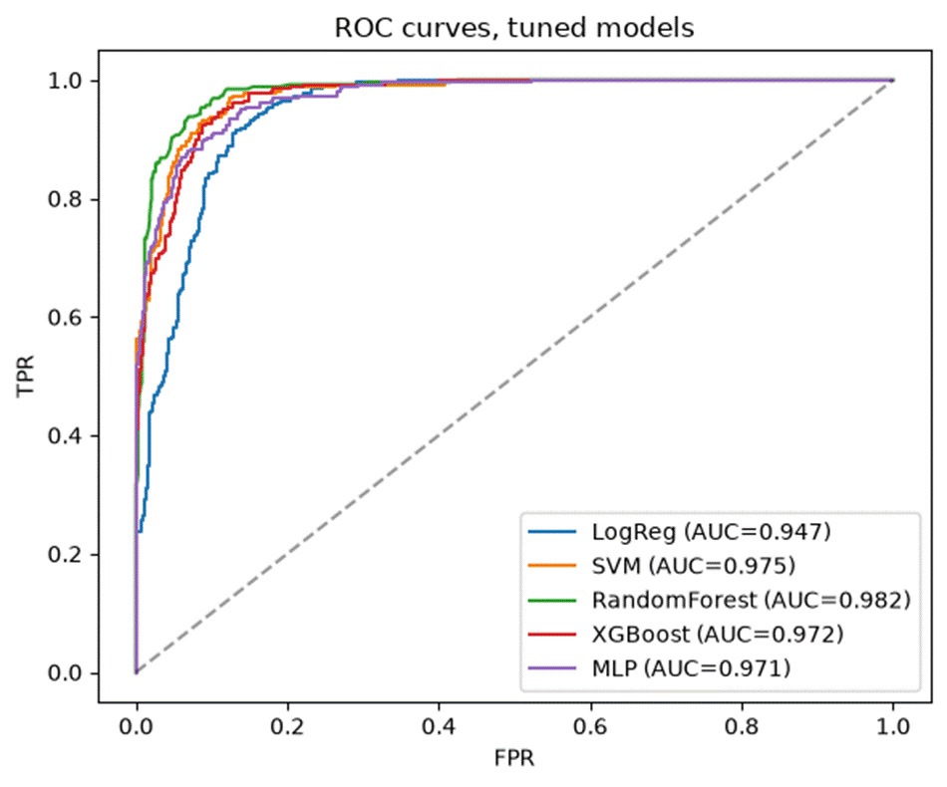
Figure 6. ROC curves, tuned models.
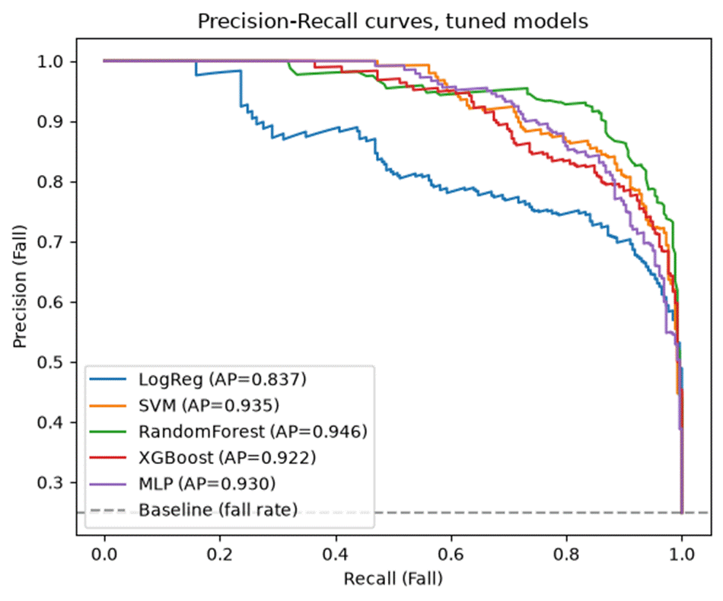
Figure 7. Precision-recall curves, tuned models. PR curves are more informative than ROC here because Fall is the minority class (~25%) and recall on Fall is the priority metric.
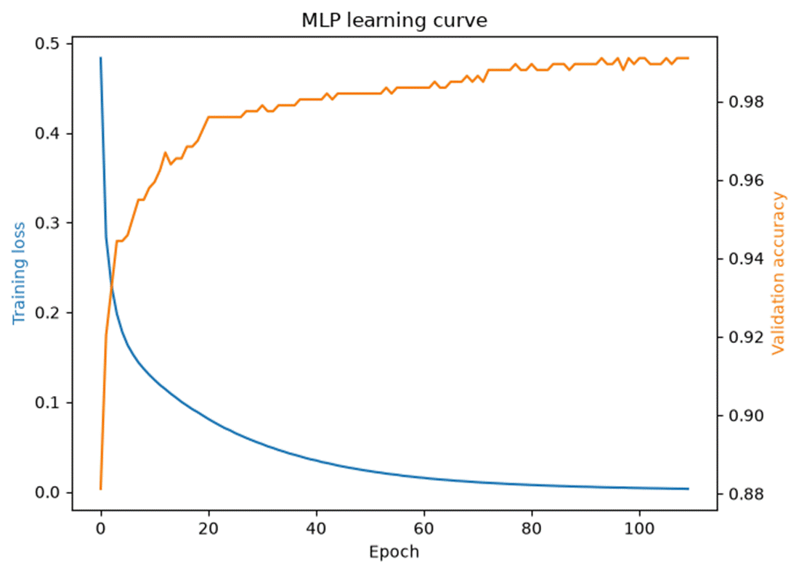
Figure 8. Tuned MLP training loss and validation accuracy per epoch, showing convergence without a widening train/validation gap (no overfitting).
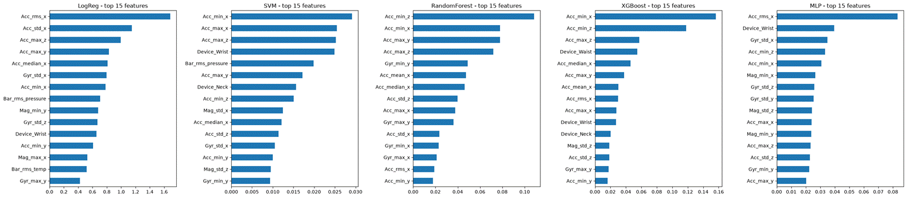
Figure 9. Top-15 features by importance for each of the five tuned models (coefficient magnitude for Logistic Regression, native impurity/gain for Random Forest and XGBoost, permutation importance for SVM and MLP).

Results:
The tuned Random Forest model was selected as the final model because it achieved the strongest overall performance across the evaluated metrics. It reached 94.3% accuracy, 90.6% precision, 86.0% recall, an F1-score of 88.3%, and a ROC-AUC of 0.982 on subjects that were completely excluded from both training and hyperparameter tuning.
The Random Forest confusion matrix in Figure 5 shows that the model correctly classified 754 out of 777 ADL recordings and 222 out of 258 fall recordings. Most errors came from false alarms rather than missed falls, which represents a safer trade-off for a fall detection application.

Feature Selection: Full (69) vs. Selected (54) Features:
Model | F1, all 69 features | F1, selected 54 features
Logistic Regression | 0.789 | 0.788
SVM (RBF) | 0.814 | 0.831
Random Forest | 0.830 | 0.883
XGBoost | 0.860 | 0.802
MLP | 0.795 | 0.846
Feature selection improved performance for SVM, Random Forest, and MLP, while having almost no effect on Logistic Regression. However, XGBoost performed better using all 69 features. This shows that feature selection does not provide a universal improvement and that its impact depends on the type of model being used. For the final Random Forest model, reducing the feature set improved both performance and interpretability by removing redundant information.

Sensor-Group Ablation (default hyperparameters):
Sensor set | LogReg | SVM | RandomForest | XGBoost | MLP
Accelerometer only | 0.792 | 0.876 | 0.889 | 0.906 | 0.906
Gyroscope only | 0.589 | 0.700 | 0.681 | 0.717 | 0.712
Magnetometer only | 0.685 | 0.557 | 0.570 | 0.591 | 0.653
Barometer only | 0.378 | 0.447 | 0.448 | 0.519 | 0.458
Acc + Gyr | 0.788 | 0.905 | 0.897 | 0.919 | 0.915
Acc + Gyr + Mag | 0.806 | 0.924 | 0.897 | 0.915 | 0.878
All sensors | 0.790 | 0.858 | 0.874 | 0.756 | 0.858

Sequence Models on the Raw Time Series (Supplementary Analysis):

The results in this section come from the project's PyTorch notebook (FallDetection_ML.ipynb) rather than the scikit-learn pipeline described above, and the two are configured differently. The notebook uses 84 engineered features and holds out three test subjects (13, 14 and 15; 1,386 recordings) instead of the two-subject, 1,035-recording split used for every table earlier in this report. The F1 values below are therefore consistent with one another but should not be read directly against the tuned-model results reported earlier.

Every model in the main pipeline reduces each 20-second recording to summary statistics: mean, median, standard deviation, minimum, maximum and RMS. Those statistics are order-invariant, meaning the samples within a recording could be shuffled in time without changing a single input value. FallAllD is a multivariate time-series dataset, so we added two models that read the signal in order, a 1D convolutional network and an LSTM, to test whether the temporal structure carries information the statistics discard.

Our first attempt at these two models gave the weakest results of anything we trained. Both read a 256-sample window of the accelerometer only, sampled at the native 238 Hz so that the window spanned just 1.1 seconds, centred on the impact peak, and each window was individually rescaled to zero mean and unit variance. The CNN reached 0.810 F1 and the LSTM 0.770. Taken on their own, those numbers look like the familiar small-data result: with roughly 4,300 training windows from 10 subjects, engineered features with tree ensembles should beat networks learning from the raw signal.

That conclusion turned out to be wrong, and the reason was in the preprocessing rather than the dataset size. We retrained both models on a corrected view of the same recordings, changing three things. First, the input carries six channels, accelerometer plus gyroscope, which is the same sensor information the tree ensembles receive. Second, the signal is decimated by a factor of four with an anti-aliasing filter to 59.5 Hz, so the same 256-sample window now spans 4.3 seconds and covers free-fall, impact and the stillness afterwards rather than the impact alone. Third, the windows are scaled by a single per-channel transform fitted on the training subjects instead of being rescaled individually, which keeps signal amplitude comparable from one window to the next. The LSTM was additionally changed from bidirectional to unidirectional and read by max-pooling over time rather than by taking its final hidden state.

Before and After (held-out test subjects):
Model | Input representation | Accuracy | Precision | Recall | F1 | ROC-AUC
1D-CNN (before) | 3-ch acc, 1.1 s, per-window scaling | 0.882 | 0.851 | 0.773 | 0.810 | 0.946
1D-CNN (after) | 6-ch acc+gyr, 4.3 s, global scaling | 0.947 | 0.937 | 0.896 | 0.916 | 0.979
LSTM (before) | 3-ch acc, 1.1 s, bidirectional, per-window | 0.844 | 0.740 | 0.802 | 0.770 | 0.886
LSTM (after) | 6-ch acc+gyr, 4.3 s, unidirectional, global | 0.913 | 0.887 | 0.838 | 0.862 | 0.958

To separate the effect of each change, we repeated the experiment on the identical six-channel 4.3-second window and varied only the scaling and the LSTM readout.

Ablation (test F1, same 6-channel 4.3 s window throughout):
Model variant | Per-window scaling | Global scaling
1D-CNN | 0.868 | 0.916
LSTM, final hidden state | 0.789 | 0.785
LSTM, max-pooled over time | 0.824 | 0.862

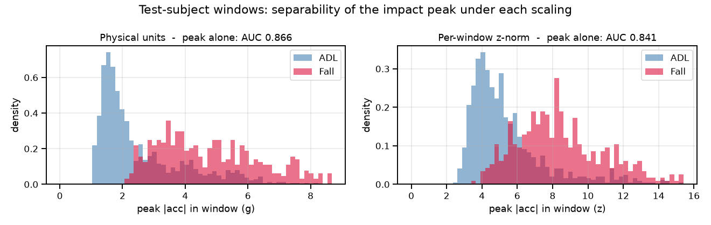
Figure 10. Distribution of peak accelerometer magnitude within each test-subject window, in physical units (left) and after per-window rescaling (right). Per-window scaling does not erase the impact peak, since a fall is also a large spike relative to its own window, but it does remove the absolute scale that lets one window be compared against another.

The two models turned out to be limited by different things. For the CNN, the window and the scaling mattered roughly equally: widening the input to 4.3 seconds and adding the gyroscope was worth 0.058 F1, and preserving physical amplitude on that same window was worth a further 0.048. At 0.916 the CNN matches the notebook's engineered-feature MLP (0.917) while using no hand-designed features at all.

For the LSTM, the scaling made almost no difference on its own, moving the final-hidden-state variant from 0.789 to 0.785, which is within run-to-run noise. The binding constraint was the readout. Because the impact sits at the centre of the window, a model that classifies from the final hidden state has to carry the impact through roughly two seconds of post-impact stillness before the classifier sees anything. Max-pooling over the hidden states lets the impact reach the classifier directly, and only then does amplitude become usable, which is why the max-pooled variant gains from the global scaling (0.824 to 0.862) while the final-state variant does not. That interaction is the clearest result in the ablation: amplitude-preserving scaling only helps a model that has some mechanism for exploiting peak magnitude.

The LSTM still trails the CNN, which is the expected outcome for a short window containing a single event. Convolution is the right inductive bias for locating a transient, and recurrence for tracking a long-range dependency, and there is no long-range dependency in a 4.3-second impact window.

This analysis does not change which model we recommend, since the tree ensembles remain ahead of both sequence models in the notebook pipeline as well. What it changes is the explanation. The reading suggested by the first attempt, that the sequence models underperform because the dataset is too small for deep learning, is not supported: the same architectures on the same recordings gained 0.106 and 0.092 F1 purely from being given a better view of the signal, with no additional data and no change in the number of training subjects. The input representation, not the dataset size, was the binding constraint.

One caveat applies to all of these numbers, including those in the main pipeline. Every model in this report classifies a pre-trimmed 20-second recording that is known to contain exactly one labelled activity, and the sequence models are additionally handed the impact location, since the window is centred on the largest accelerometer peak. That is precisely the setting in which a single global maximum-acceleration feature is hardest to beat. A deployed detector receives a continuous stream with no trial boundaries and no impact marker, and would need to be judged on detection latency and false alarms per hour, neither of which this evaluation measures.

Research Questions:

RQ1. How do different supervised machine learning algorithms perform in the classification of falls vs. ADLs from wearable sensor features? Which has the highest classification accuracy?
Five supervised machine learning models were evaluated: Logistic Regression, Support Vector Machine (SVM), Random Forest, XGBoost, and Multi-Layer Perceptron (MLP). Overall, the tuned Random Forest model achieved the strongest performance, reaching 94.3% accuracy, 86.0% recall, 88.3% F1-score, and 0.982 ROC-AUC on subjects that were completely excluded from training and hyperparameter tuning.
The MLP was the strongest neural network model after tuning, achieving an F1-score of 0.846, while SVM performed well before tuning but decreased after its tuned parameters did not generalize as well to the held-out subjects. XGBoost showed the largest improvement from tuning, increasing its F1-score from 0.764 to 0.802, but it still remained below Random Forest and MLP performance. Logistic Regression consistently performed the weakest, suggesting that the separation between falls and ADLs is not fully captured by a simple linear decision boundary.
Overall, the results indicate that Random Forest was the most effective model for this dataset, providing a strong balance between accuracy, recall, interpretability, and computational efficiency.
RQ2. Which sensing methods provide the most beneficial prediction information for accurate classification?
The results show that accelerometer-based features provided the most useful information for distinguishing falls from ADLs. Features related to acceleration magnitude, especially vertical (z-axis) minimum values, maximum values, standard deviation, and RMS, consistently appeared among the most important features across models. This matches the physical characteristics of a fall, where a brief decrease in acceleration is followed by a large impact.
Adding gyroscope features generally improved model performance, suggesting that rotational movement also provides useful information about fall events. Magnetometer features provided smaller and more inconsistent improvements depending on the model. In contrast, barometer features contributed very little and sometimes reduced performance when combined with the other sensors.
The sensor ablation results suggest that fall detection in this dataset is primarily driven by acceleration-based movement patterns, with gyroscope data providing additional useful context.
RQ3. How impactful is feature selection across linear and non-linear classification models?
Feature selection improved performance for several models but did not provide a universal improvement. Reducing the original 69 engineered features to 54 selected features improved SVM, Random Forest, and MLP performance, while Logistic Regression remained almost unchanged.
However, XGBoost performed better using the full 69-feature dataset, showing that some models can benefit from retaining additional correlated information. This suggests that feature selection should be evaluated based on the specific model rather than automatically assumed to improve performance.
Overall, feature engineering and preprocessing were important steps in building the classification pipeline, but the impact of feature reduction depended on the characteristics of each algorithm.
RQ4. Does device placement information improve fall detection classification accuracy?
Model | Waist F1 | Wrist F1 | Neck F1
Logistic Regression | 0.881 | 0.746 | 0.812
SVM (RBF) | 0.873 | 0.783 | 0.872
Random Forest | 0.931 | 0.828 | 0.927
XGBoost | 0.912 | 0.700 | 0.877
MLP | 0.949 | 0.794 | 0.878

Device placement had a smaller impact than expected compared to the differences between sensor locations themselves. Adding device placement as an additional feature produced mixed results, slightly improving some models while decreasing performance for others.
The more consistent finding was that waist and neck sensors significantly outperformed wrist sensors across all models. For example, the Random Forest model achieved F1-scores of 0.931 using waist data and 0.927 using neck data, compared to only 0.828 using wrist data. This suggests that torso-mounted sensors capture the free-fall and impact patterns of a fall more clearly, while wrist sensors are more affected by normal daily movements that can resemble fall-related impacts.
RQ5. Are any machine learning models sufficient to predict fall classification based only on the dataset used in this project?
The results suggest that the tested models are capable of accurately distinguishing falls from ADLs within this dataset, with the tuned Random Forest achieving the strongest performance. However, the models are not yet sufficient for direct real-world deployment without additional validation.
A major limitation is that the FallAllD dataset contains simulated falls performed by a relatively small group of healthy volunteers. Real-world falls among older adults may involve different movement patterns due to age, mobility limitations, and health conditions. Additionally, the held-out test set contained only two subjects, meaning performance estimates may still be influenced by individual differences.
Therefore, while the results demonstrate that machine learning models can successfully classify falls using wearable sensor features, additional testing on a larger and more representative population would be required before considering clinical or commercial use.

Discussion:
Some of the key findings were that the Random Forest was the strongest overall classifier for determining whether or not it was an activity of daily life or a fall. It was trained on 54 features derived from accelerometer, gyroscope and magnetometer data and it was able to generalize well to the test data, meaning unseen subjects with a F1-score of 0.883 and a ROC-AUC of 0.982. We also found that hyperparameter tuning had mixed results across the different models. It helped 3 of 5 models substantially, had little effect on one, and hurt one (SVM) due to the small number of subjects in the held out set. Another interesting finding was that the barometer channel was largely unhelpful and did not provide additional value. In some cases it actually reduced performance on the model compared to using the other sensors alone. And finally, we determined that the wrist-worn sensors were consistently more difficult to classify correctly than waist or neck worn sensors, across every model tested. This suggests that sensor placement is important for fall detection accuracy.
Some of the strengths of the model would be that there was a strong recall and ROC-AUC on subjects genuinely unseen during training and tuning. This means that the subject wise split was important and helped provide a better realistic estimate of a real world example since it had all of the recordings for one individual instead of randomly splitting up the recordings. Additionally, the model uses a relatively small and interpretable feature set of 54 features. They each have clear physical meaning which made it easier to understand which aspects of an individuals movement contributed to the predictions. Another advantage, or strength would be the low computational cost. A Random Forest is generally cheap to run on a wearable unlike a deep learning model.
Some of the limitations were that the first test set only contained 2 subjects (1,035 recordings). This means that individual differences between subjects can have a huge effect on performance. This was seen in the SVM model where the tuning actually caused a decrease in test performance. Another limitation is that all falls in FallAllD are simulated by relatively young, healthy volunteers under controlled conditions. This means that a real fall by an older adult may look different. And finally, the hyperparameter tuning process was limited by the size of the dataset. The grouped cross-validation used only a small number of folds across the available training subjects, which ultimately created some uncertainly when selecting the best model settings
Sources of Error:
The confusion matrices (Figure 5) show that for every model, the most common error was false positives where normal ADL movements were incorrectly classified as falls. These errors were most likely caused by activities such as quickly sitting down, jumping or anything else that could simulate the movement of a fall. This issue was a bigger issue with the sensor worn on the wrist because the arm moves up and down a lot quicker and more jaggedly than the waist or neck.
Ethical Considerations:
A wearable fall detection system designed for older adults introduces several ethical considerations. Missing a real fall is a serious concern because false negatives could delay medical assistance or help from family members. This means that we may need to prioritize recall even if that results in more false alarms. Additionally, privacy is a big issue. The device would be monitoring continuous movement, which means that its collecting all your personal activity data. Users need to be told information about how and where their data is collected and stored, and also who accesses it. Additionally, the model was trained on a relatively small population of all healthy individuals. This means that performance could differ across people of different ages, health conditions and mobility levels. This device should be tested on a more diverse population before being deployed as a reliable fall detection monitor.
Possible Improvements:
Some possible improvements would be to diversify and expand the dataset by collecting data from more participants, including older adults with different mobility levels and using actual fall events to test the data set. Another improvement would be to build on the supplementary sequence-model results reported earlier. Those experiments show that the 1D-CNN and LSTM were limited by how the signal was presented to them rather than by the amount of data available: widening the input window, adding the gyroscope channels and preserving physical signal amplitude raised the CNN from 0.810 to 0.916 F1 and the LSTM from 0.770 to 0.862 on the same recordings. Pushing this further would most likely mean evaluating them on a continuous sliding window rather than a pre-trimmed recording. Finally, we could explore more sensor fusion and combine information from multiple device locations. Since the waist, neck and wrist sensors capture different aspects of movement, combining their signals may improve reliability instead of analyzing each one separately.

Real-World Application:
The tuned Random Forest model could realistically be used as a fall detection system for wearable devices. Using accelerometer and gyroscope data and statistics collected over short time windows, the model could run on a portable or wearable device. It could also run on a connected smartphone if the user always had it with them. This device would continuously monitor and analyze the incoming sensor data which would then send an alter to the wearer, caregiver, or monitoring service if it detected a fall or possible injury. Since the random forest model uses the 54 engineered features instead of a large neural network, it is efficient enough to just run locally on a low powered device without relying on constant internet connection.
This could be particularly helpful for older adults living independently, whose caregivers or family could be notified automatically if a fall occurs and the patient doesn’t check in right away. Additionally, it could benefit assisted-living and long-term care facilities, where staff cannot monitor every resident at a time. In addition, it could benefit individuals recovering from surgery or an injury.

Some challenges when deploying it could be connectivity and battery life, meaning that a real product needs a plan for alerting a caregiver or family member if the internet is down or unavailable. It also needs to run continuously without draining the battery super fast so it can be worn all day. Another challenge would be privacy and consent. This could be an issue because continuously monitoring someone’s movements means that they would have to consent to how their data is collected, used and stored. And finally, another challenge could be that the model was trained on simulated falls by young, healthy volunteers. This means that real falls by older adults with different gait, balance, and injury patterns may look different. Therefore, the performance should be re-tested and validated on an older or injured population before deployment.

Conclusion:
The purpose of this project was to build and evaluate a complete machine learning pipeline for wearable-sensor fall detection using the FallAllD dataset. The pipeline included all steps from processing raw sensor files and cleaning the data to feature engineering, model training, hyperparameter tuning, and evaluation on subjects that were not included during training or model selection.
Five different machine learning models were compared, with the tuned Random Forest model achieving the best overall performance. Using 54 engineered features from accelerometer, gyroscope, magnetometer, and barometer data, the model reached 94.3% accuracy, 86.0% recall, and a ROC-AUC of 0.982 when tested on unseen subjects. These results show that effective fall detection at this dataset size does not necessarily require a highly complex model. A compact, interpretable, and computationally efficient model can achieve strong performance while being more practical for wearable devices.
The analysis also showed that sensor selection and placement have a major impact on performance. Accelerometer-based features, especially those related to movement intensity and impact, provided the most useful information for distinguishing falls from normal activities. In comparison, magnetometer and barometer features contributed less, and wrist-based sensors were more challenging than torso-based placements. Overall, the results suggest that careful feature engineering and sensor selection may be just as important as increasing model complexity when developing practical wearable fall detection systems.

Future Work:
Some future work that we could do would be to validate the model on a larger and more demographically diverse subject pool. So that would include older adults and people with mobility impairments. Additionally, we could incorporate real-world (non-simulated) fall or near-fall data where ethically and practically feasible. Another direction is to develop the raw-signal deep learning models further. The supplementary analysis above shows that a 1D-CNN reading the six-channel waveform matches the best engineered-feature neural network without using any hand-designed features, so the open question is no longer whether these models can work at this dataset size but how far they can be pushed. Evaluating them on a continuous stream, with detection latency and false alarms per hour as the metrics, would be the most useful next step. We could also investigate multi-device sensor fusion. This means that we could combine the waist and wrist together, or other combinations, rather than evaluating each device position independently.

References:
[1] M. Saleh and R. Le Bouquin Jeannès, FallAllD: A Comprehensive Dataset of Human Falls and Activities of Daily Living, IEEE DataPort, 2020. [Online]. Available: https://ieee-dataport.org/open-access/fallalld-comprehensive-dataset-human-falls-and-activities-daily-living

